WellnessHub – Personalized Wellness Management Program

System Proposal

CP3540 – Applied ASD Project
2026 07 16
Table of Contents

- Executive Summary 1
- Proposed Features and Objectives 2
- Requirements 3
- Architecture and Technology Stack 8
- Deployment 13
- The Team 14
Executive Summary

People are constantly bombarded with messages about health and wellness throughout broadcast, streaming, and social media. They’re told to do one thing, not do another, do these things but not those things, purchase this product or service, and here’s the latest shocking study finding that should lead a person to completely upend their life and habits. On top of this, they are often pressured to tell the entire world about every last activity in which they engage, making every personal effort into a competition. It can be overwhelming for someone who just wants to feel a bit better in their body and mind, and would like a predictable, consistent source of information, suggestions, and support.

A survey of health and wellness applications by Alslaity, et al (2022) found that most existing applications employed an average of 12 behaviour change strategies. The survey noted that “[t]he use of multiple strategies [...] may cause cognitive overload because the more the strategies, the more likely the app becomes too complex.“ The study authors recommended designers choose strategies “cautiously”, so as to avoid overloading users with information and options. Some of the most common and effective features were self-monitoring behaviour, reviewing and monitoring progress, and personalization of the app for a user’s goals. Among other things, the authors recommended focusing apps on general health and wellbeing, meditation, and helping users track their progress.

WellnessHub aims to be an app for people who want gentle guidance and support through their personal wellness journey. The app will provide users with suggestions for meals, simple physical activities, and mindfulness activities based on data they provide, and allow them to track things like their water intake, physical activity, and emotional state, all accessible through a dashboard. New content can be added using a simple CMS utilizing Markdown, with access granted to vetted professionals in the appropriate fields.

The app will be built on well-tested, well-supported Web development technologies, and once in production will be hosted in the cloud. As the app will host user-provided, personally-identifiable information related to their health, security and privacy are paramount concerns.
Proposed Features and Objectives

The goal of WellnessHub is to create a secure and easy-to-use application that helps people manage their overall wellness. Users will be able to manage their accounts, track water intake, exercise and mood, and view their progress from one dashboard. The application will also suggest meals, activities and mindfulness exercises based on each user’s preferences and goals. It will be designed to work well on both computers and mobile devices. Short-term performance can be measured in terms of successfully-delivered features and service reliability. In the long term, success can be measured based upon steady service utilization and recorded wellness improvements.

Features include:
- Web-based dashboard
- Allow user to browse recipes and meals by cuisine
- Suggest simple physical activities
- Track water intake and emotional state
- Track exercise and walking
- Provide guidance for yoga and stretching
- Suggest mindfulness activities based on provided data
- Allow addition of new wellness content through Markdown-based entry
- Cloud-based NoSQL storage
- Secure storage of user data

Requirements

Requirement | Priority | Difficulty
Functional requirements
1. Create new user profile
-User creates a new profile | Must | Low
-User enters height, weight, heart rate, calorie goal, activity level, food preference, wellness goal | Should | Low
-User receives initial suggestions for meal, exercise, and wellness plans based on input | Should | Medium
1.1 Update profile
-User selects profile settings | Must | Low
-User changes display name | Could | Low
-User uploads display picture | Could | Medium
-User selects password change function | Must | Medium
1.2 Delete profile
-User selects account deletion | Must | Low
-User is given option to download data prior to deletion | Could | Medium
-User confirms account deletion and account is deleted | Must | Low
2. Access dashboard and modules
-User logs in | Must | Medium
--User selects password reset function if necessary | Must | Medium
-User views progress dashboard | Must | Medium
-User selects desired module | Must | Low
-User interacts with module | Must | Medium
-User returns to dashboard | Must | Low
-User logs out at end of session | Must | Medium
2.1 Meal planning module
-User selects per-day or per-week planning | Should | Medium
-User browses possible recipes | Must | Low
-User chooses a meal per time period | Should | Medium
-System returns a suggested grocery list | Could | Medium
2.2 Global recipe explorer
-User browses recipes by cuisine, other filters (dietary restrictions, vegan/vegetarian, etc.) | Must | Medium
2.3 Water tracking
-User views water consumption over a selected period of time | Should | Medium
-User enters volume of water consumed on a given day | Must | Low
2.4 Exercise tracker
-User views exercise and walking history | Should | Medium
-User views potential walking and exercise plans | Must | Low
-User logs plans they carried out on a given day | Should | Medium
2.5 Yoga and stretching guidance
-User views yoga and stretching history | Should | Medium
-User views potential yoga and stretching courses | Must | Low
-User logs courses they carried out on a given day | Should | Medium
2.6 Mood check-in
-User views mood tracking display | Should | Medium
-User logs current mood from dropdown list | Must | Low
-User receives suggestions for activities based on mood trend | Could | High
3. Create new content provider profile
-Administrator creates content provider profile | Should | Medium
-Provider receives initial login credentials | Should | Medium
-Provider logs in and creates a new password | Should | Medium
-Provider enters display name | Could | Low
-Provider uploads display picture | Could | Medium
4. Create new content
-Provider accesses dashboard showing articles they’ve saved and published | Must | Medium
-Provider selects new article entry function | Must | Low
-Provider enters new article in Markdown format, selects category into which it will be filed | Must | High
-Provider saves article draft for review | Should | Low
-Provider publishes article | Must | Medium
4.1 Update content
-Provider/administrator selects article to modify | Must | Medium
-Provider/administrator edits article | Must | Medium
-Provider/administrator saves edited article for review | Should | Low
-Provider/administrator publishes edited article | Must | Medium
4.2 Delete content
-Provider/administrator selects article to delete | Should | Low
-Provider/administrator confirms deletion | Should | Low
5. Administration
-Administrator accesses administration dashboard | Should | Medium
-Administrator creates new account | Must | Medium
-Administrator selects account to modify/delete | Must | Medium
-Administrator selects articles to edit, publish/unpublish, delete | Must | Medium
Non-functional requirements
6. Operational
-System should be accessible via web | Must | Medium
-Front end and middleware should be platform-agnostic | Should | Medium
-Database backend should be built upon a NoSQL platform | Should | High
-Data should be backed up daily | Could | High
-System should be deployable via containers | Could | High
-Audio and video should be embedded | Could | Medium
7. Performance
-Access to web interface elements should be as close to instantaneous as possible | Must | Medium
-Calculation of wellness scores and suggestions should take no more than 10 seconds from request to display | Should | Medium
-Audio and video streaming should be low latency | Could | High
8. Security
-User data should be encrypted in transit and at rest | Must | High
-Users should only be able to access their own data | Must | Medium
-Login credentials should be securely hashed | Must | Low
-Administrator logins should use 2FA | Should | High
9. Cultural, legal, and political
-Personal data should be treated as health-related PII, with appropriate protections | Must | High
-Personal data should be handled in a manner compliant with privacy legislation in potential jurisdictions of operation | Must | High
-Information on food and wellness practices should be presented in a manner appropriate to cultural context | Should | Medium

Performance
WellnessHub will be designed to load pages and process information quickly. Actions such as opening the dashboard, recording an activity and checking progress should feel fast and smooth. The main features will also be tested to make sure they work reliably.

Scalability
The application will be built in separate modules, making it easier to add new features in the future. Its cloud-ready design will allow it to support more users, information and wellness content as it grows. More wellness tools and services could also be added later. The application will be designed to scale horizontally, through containerized cloud deployments or even a transition to serverless microservices.

Security
WellnessHub will protect users’ personal information by securely hashing passwords and using HTTPS for communication. Users will only be able to access their own information, while administrators and content providers will receive access based on their roles. User data will be encrypted in place and in transit. The team will follow appropriate privacy and security practices when storing and using personal data.

Architecture and Technology Stack

WellnessHub will use a simple three-tier web architecture. Users will interact with the React frontend, which will send secure REST API requests to the Node.js and Express.js backend. The backend will manage user accounts, wellness recommendations, tracking features, and content. MongoDB will store user profiles, recipes, articles, mood entries, water records, exercise records, and progress information. JWT will be used to authenticate users and protect private routes.
Architecture Diagram
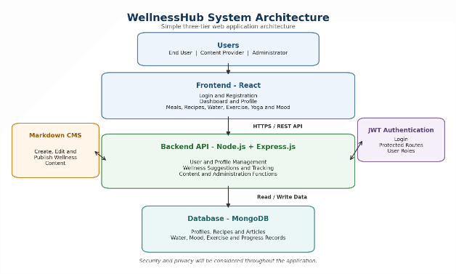
Figure 1. WellnessHub system architecture.

Component Diagram
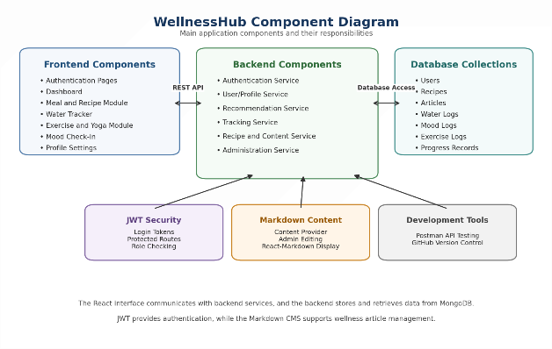
Figure 2. Main WellnessHub software components.
Technology Stack
Component | Technology
Frontend | React, React-Markdown
Backend | Node.js, Express.js
Database | MongoDB
Authentication | JWT
API Testing | Postman
Version Control | GitHub

Proposed User Interface

The following UI mockups show simple example screens for the WellnessHub application. These designs illustrate how the main user pages may look in the final system.

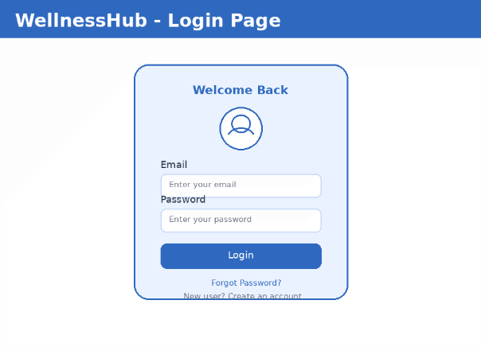
Figure 3. Sample login screen for user sign-in and account access.

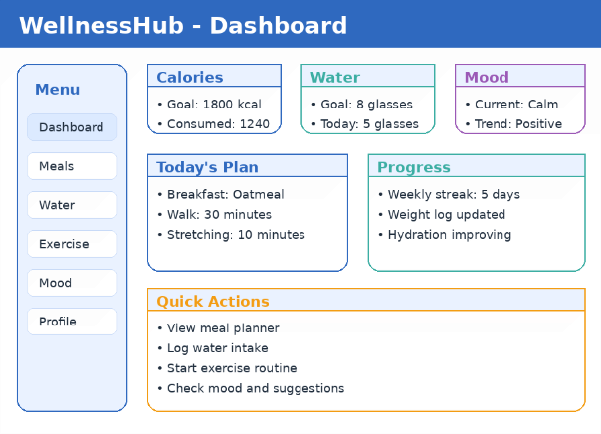
Figure 4. Sample dashboard showing wellness summary and quick actions.

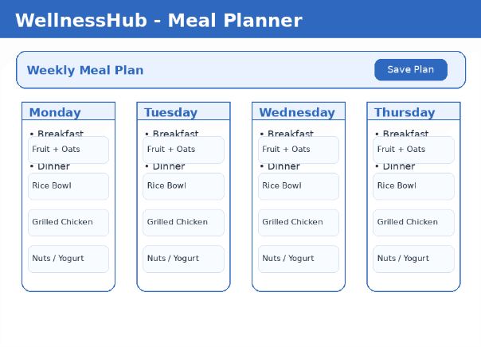
Figure 5. Sample weekly meal planner interface for users.

Deliverables and deployment

A successful development project will provide:

- A functional WellnessHub web application
- User dashboard and wellness-tracking features
- Secure user registration and login
- Cloud-hosted database and deployed application
- Source code and technical documentation
Prototype deployment will be to a self-hosted instance. Future developments will shift application deployment to a cloud provider. WellnessHub will be structured to make possible an eventual transition to serverless microservices.

The Team

WellnessHub comes from a team of new programmers eager to deliver an application that works for its users and their needs, rather than exploiting them.

Anumol Thomas – Design lead
Anumol Thomas is a Software Development student with a strong academic record and a passion for learning emerging technologies. She enjoys applying programming, problem-solving, and teamwork skills to develop practical software solutions through collaborative projects.

Josh Ennis – Middleware development
Josh Ennis is a Software Development student with a strong desire to learn about programming. He uses his skills in Python, Java, JavaScript, and SQL to solve problems regarding software applications. He desires to apply himself and learn more about software.

Tyler Bown – Platform development, fitness advisor
Tyler Bown brings years of interest in health and fitness to WellnessHub, along with fresh knowledge of Java, Python, Web development, and many other languages. When he’s not working out, he builds data analysis tools and develops flexible solutions.

Mark Phoenix – Project spokesperson, database development
Mark Phoenix spent twenty-five years in media with longstanding side interests in networking and systems administration. To this, he brings new skills in Python, Java, JavaScript, React, SQL and NoSQL, and cloud infrastructure. He enjoys making things work and fixing things that don’t. He wants to create applications centered on end users and their needs.

Alaa Alslaity, Banuchitra Suruliraj, Oladapo Oyebode, Jonathon Fowles, Darren Steeves, And Rita Orji. 2022. Mobile Applications for Health and Wellness: A Systematic Review. Proc. ACM Hum.-Comput. Interact, 6, EICS, Article 171 (June 2022), 29 pages, https://doi.org/10.1145/3534525

